**ZOMATO SQL ANALYSIS**

**Data Import and Table Creation**

Successfully imported 5 CSV files into SQL Server to create the foundational database tables:

Orders

Customers

Deliveries

Restaurants

Riders

* Adjusted data types during import to ensure compatibility and efficiency (e.g., INT, VARCHAR, DATE).
* Applied necessary constraints such as PRIMARY KEY to enforce data integrity and uniqueness.

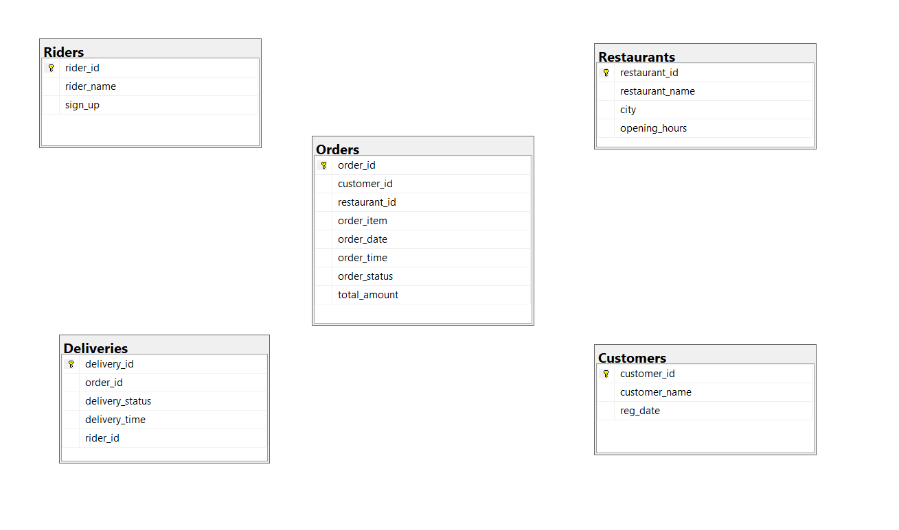

ALTER TABLE Deliveries

ADD CONSTRAINT FK_Deliveries_Orders

FOREIGN KEY (Order_id) REFERENCES Orders(order_id);

ALTER TABLE Deliveries

ADD CONSTRAINT FK_Deliveries_Orders

FOREIGN KEY (Order_id) REFERENCES Orders(order_id);

ALTER TABLE Orders

ADD CONSTRAINT FK_Orders_Customer_id

FOREIGN KEY (customer_id) REFERENCES Customers(customer_id);

ALTER TABLE Orders

ADD CONSTRAINT FK_Orders_Restaurant_id

FOREIGN KEY (restaurant_id) REFERENCES Restaurants(restaurant_id);

ALTER TABLE Deliveries

ADD CONSTRAINT FK_Deliveries_rider_id

FOREIGN KEY (rider_id) REFERENCES Riders(rider_id);

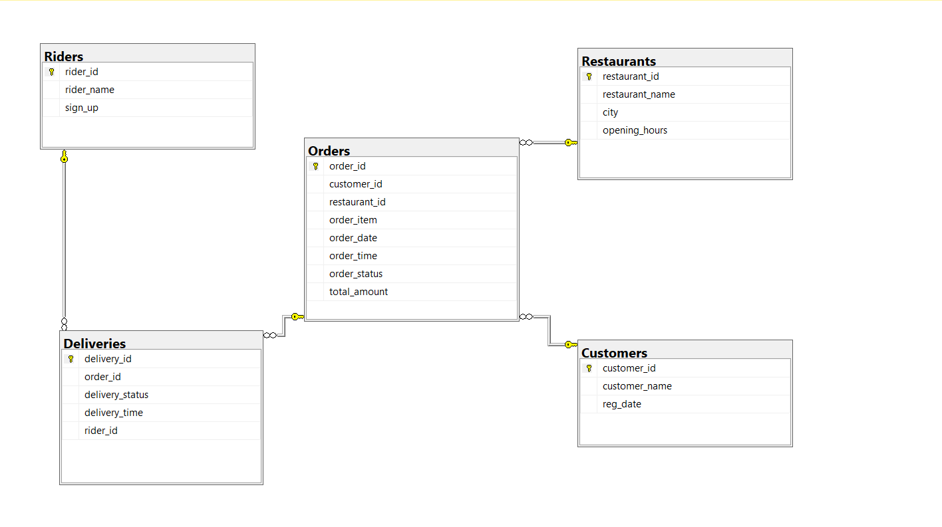

Established a relational database ready for data analysis, reporting, and optimization.

The design ensures:

* Data Integrity: Only valid data can be inserted or updated.
* Efficient Queries: Optimized structure for faster query performance.
* Database is now robust and scalable for real-world business applications.

**Exploratory Data Analysis**

SELECT * FROM Customers

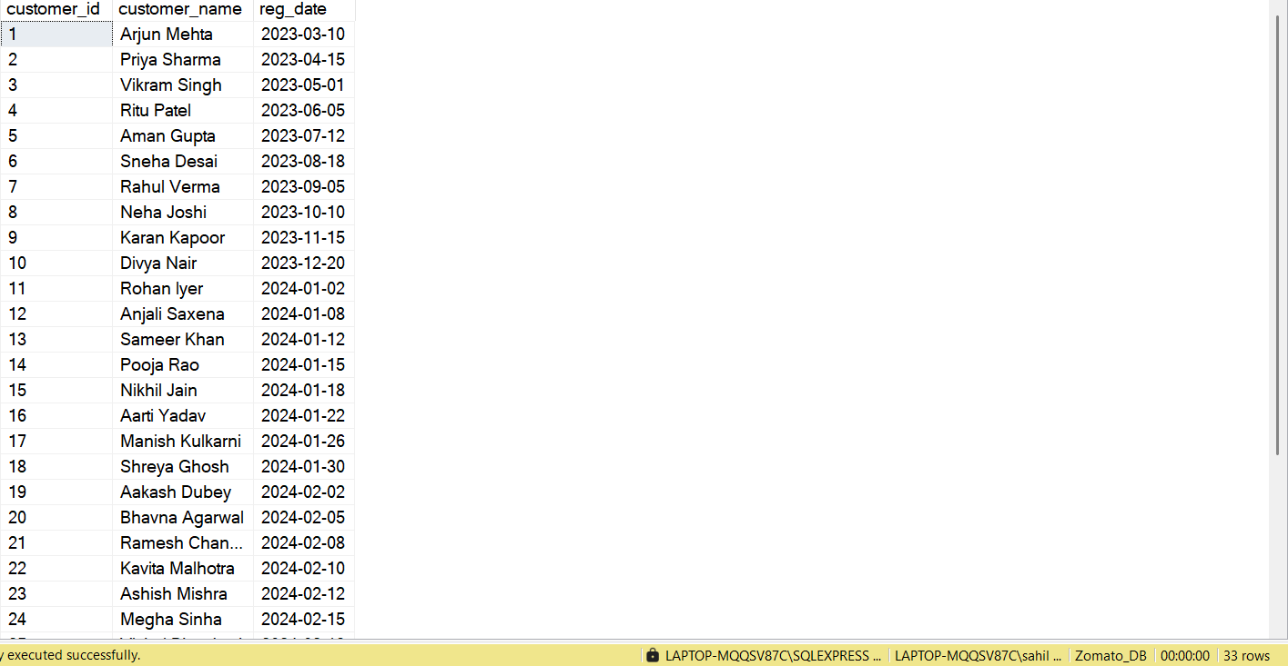

SELECT * FROM Orders

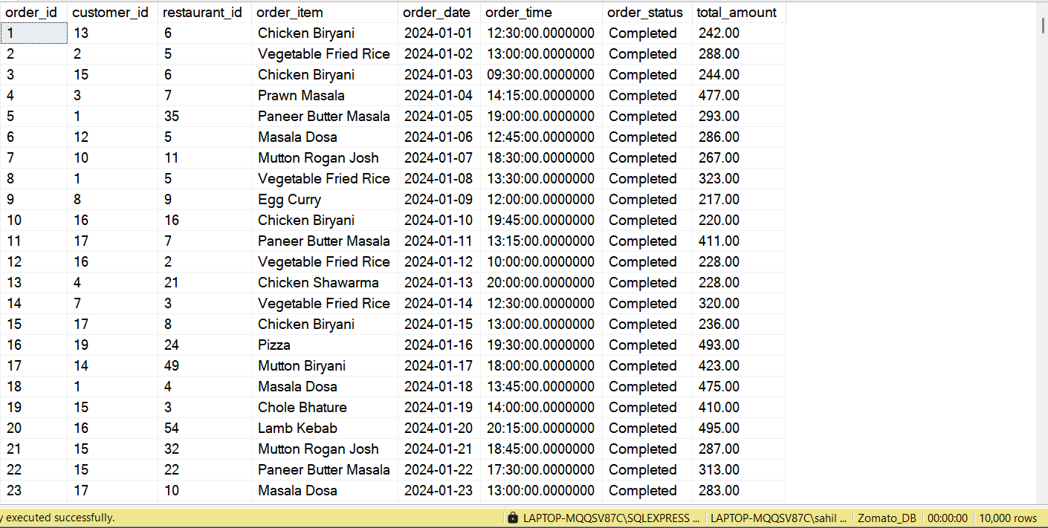

SELECT * FROM Riders

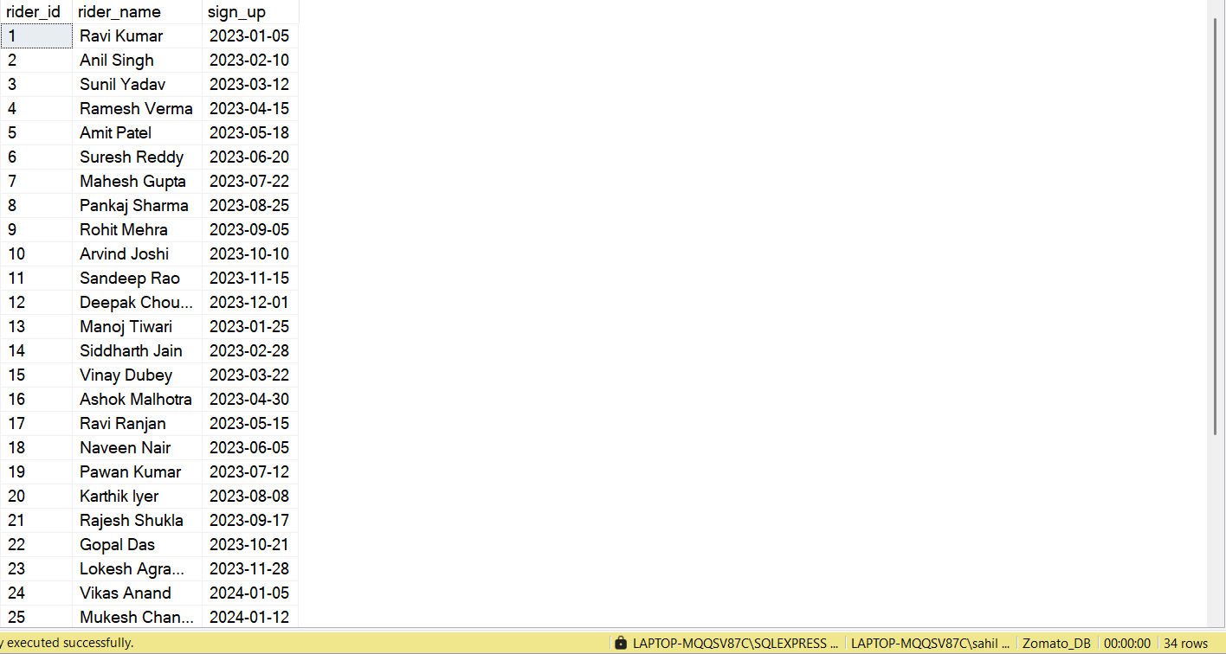

SELECT * FROM Deliveries

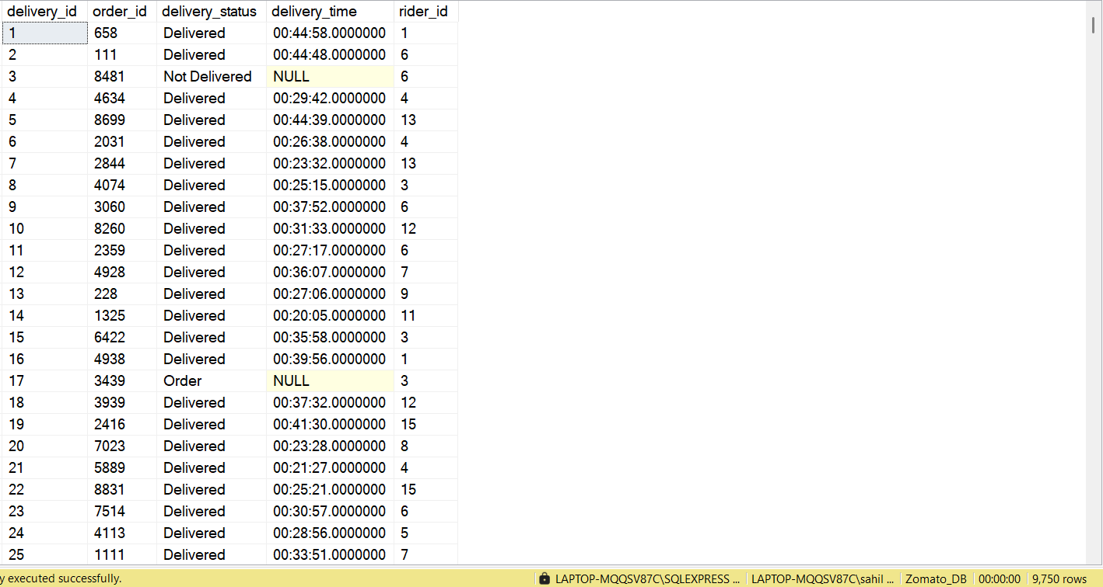

SELECT * FROM Restaurants

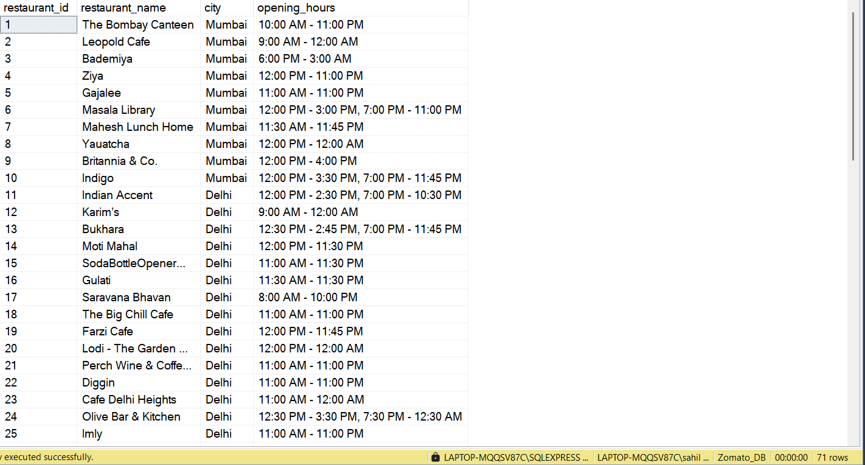

SELECT * FROM Customers

WHERE

customer_id IS NULL OR

customer_name IS NULL OR

reg_date IS NULL

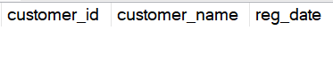

SELECT * FROM Orders

WHERE

order_id IS NULL OR

order_item IS NULL OR

order_date IS NULL OR

Order_time IS NULL OR

order_status IS NULL OR

total_amount IS NULL



SELECT * FROM Riders

WHERE

rider_id IS NULL OR

rider_name IS NULL OR

sign_up IS NULL



SELECT * FROM Restaurants

WHERE

restaurant_name IS NULL OR

opening_hours IS NULL OR

city IS NULL

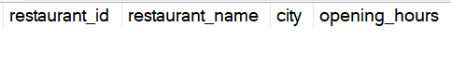

SELECT * FROM Deliveries

WHERE

delivery_id IS NULL OR

order_id IS NULL OR

rider_id IS NULL OR

delivery_status IS NULL

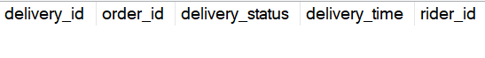

The last order's date in the Orders table

SELECT MAX(order_date) Last_Order_Date FROM Orders



here we are considering Today's date as this

SELECT CAST(GETDATE() AS date) Todays_Date



Q1 Write a query to find the top 5 most frequently ordered dishes by customer called "Arjun Mehta" in the last 2 year

SELECT DATEADD(YEAR,-2, CAST(GETDATE() AS date)) CurrentDate



SELECT customer_name, Dishes, Rank_of_dishes FROM

( SELECT

c.customer_id,

c.customer_name,

o.order_item as Dishes,

COUNT(o.order_item) Nr_of_time_item_Order,

DENSE_RANK() OVER(Order by COUNT(o.order_item) DESC) Rank_of_dishes

FROM Orders o

JOIN Customers c

ON o.customer_id = c.customer_id

WHERE

c.customer_name = 'Arjun Mehta'

AND

order_date > DATEADD(YEAR,-2,CAST(GETDATE() AS date))

GROUP BY

c.customer_id,

c.customer_name,

o.order_item

) t1

WHERE Rank_of_dishes <= 5

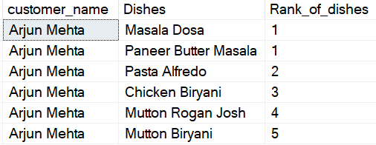

Q2 Popular Time slot: Identify the time Slots during which the most orders are placed. based on 2 hours interval

Here for 00:59:59--> 0 and 1:59:59-->1, so 0 to 1 is Slot of 2 hours

WITH Popular_time_slot

AS

(

SELECT *,

CASE

WHEN DATEPART(HH,order_time) BETWEEN 0 AND 1 THEN '00:00 - 02:00'

WHEN DATEPART(HH,order_time) BETWEEN 2 AND 3 THEN '02:00 - 04:00'

WHEN DATEPART(HH,order_time) BETWEEN 4 AND 5 THEN '04:00 - 06:00'

WHEN DATEPART(HH,order_time) BETWEEN 6 AND 7 THEN '06:00 - 08:00'

WHEN DATEPART(HH,order_time) BETWEEN 8 AND 9 THEN '08:00 - 10:00'

WHEN DATEPART(HH,order_time) BETWEEN 10 AND 11 THEN '10:00 - 12:00'

WHEN DATEPART(HH,order_time) BETWEEN 12 AND 13 THEN '12:00 - 14:00'

WHEN DATEPART(HH,order_time) BETWEEN 14 AND 15 THEN '14:00 - 16:00'

WHEN DATEPART(HH,order_time) BETWEEN 16 AND 17 THEN '16:00 - 18:00'

WHEN DATEPART(HH,order_time) BETWEEN 18 AND 19 THEN '18:00 - 20:00'

WHEN DATEPART(HH,order_time) BETWEEN 20 AND 21 THEN '20:00 - 22:00'

WHEN DATEPART(HH,order_time) BETWEEN 22 AND 23 THEN '22:00 - 00:00'

END AS Time_Slot

FROM Orders

)

SELECT Time_Slot, COUNT(*) Total_Orders FROM Popular_time_slot

GROUP BY Time_Slot

ORDER BY COUNT(order_id) DESC

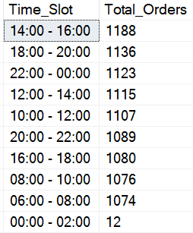

Q3 Order Value Analysis: Find the Average Order value per customer who has placed more than 750 orders

Return Customer_name, and AOV(Average Order Value)

SELECT

c.customer_id,

c.customer_name,

CAST(AVG(O.total_amount) AS decimal(10,2)) Avg_Order_Value

FROM Customers c

JOIN Orders o

ON c.customer_id = o.customer_id

GROUP BY c.customer_id, c.customer_name

HAVING

COUNT(o.order_id) > 750

ORDER BY

AVG(total_amount) DESC

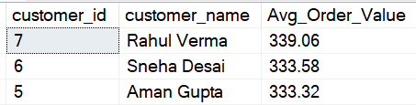

Q4 High Value Customers: List the Customers who have spent more than 100K in total on food orders.

Return customer_name, and customer_id

SELECT

c.customer_id,

c.customer_name,

SUM(o.total_amount) Total_Spent

FROM Customers c

JOIN Orders o

ON c.customer_id = o.customer_id

GROUP BY c.customer_id,

c.customer_name

HAVING

SUM(o.total_amount) > 100000

ORDER BY

SUM(o.total_amount) DESC

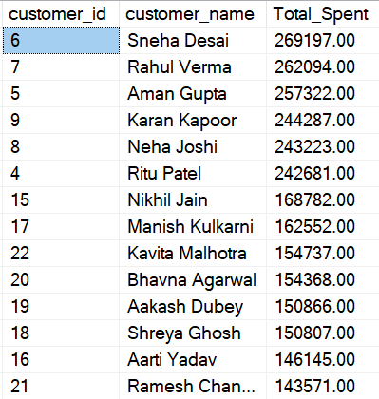

Q5 Orders without Delivery: Write query to find orders that were placed but not delivered.

-Return each restaurant name, city and number of not delivered orders

Here we have to include both cases where orders was not fulfilled and Delivery status is "Not delivered"

SELECT

r.restaurant_name,

r.city,

COUNT(o.order_id) AS Total_Not_Delivered_Orders

FROM

Orders o

LEFT JOIN Deliveries d

ON o.order_id = d.order_id

LEFT JOIN Restaurants r

ON r.restaurant_id = o.restaurant_id

WHERE

d.delivery_status = 'Not Delivered'

OR d.delivery_status IS NULL -- Capture orders with no delivery entry

GROUP BY

r.restaurant_name, r.city

ORDER BY

Total_Not_Delivered_Orders DESC;

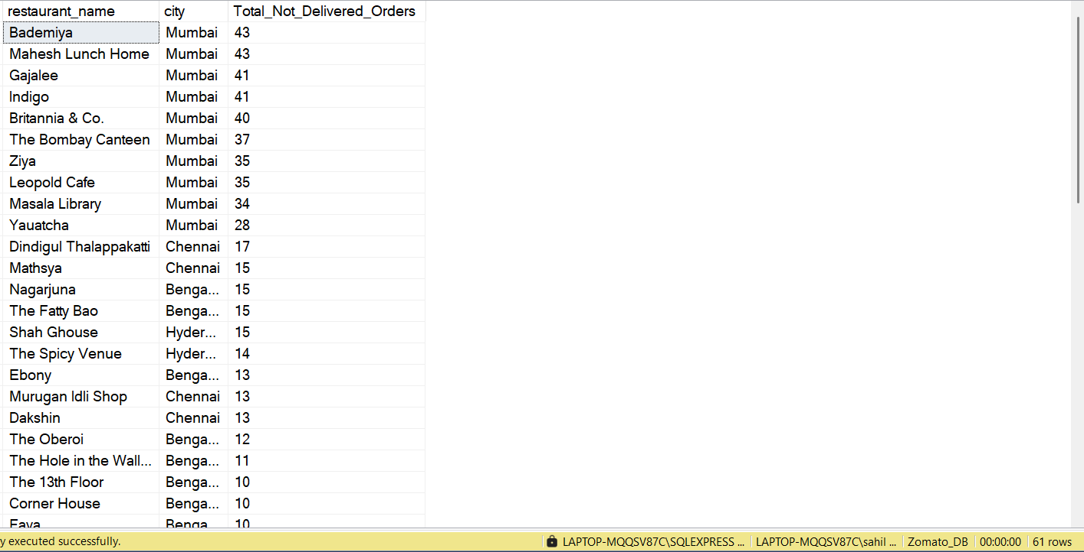

Q6 Restaurant Revenue Ranking: Rank restaurants by their total reveneu from the last year. including their name, Total Revenue, and rank within their city

SELECT

r.city,

r.restaurant_name,

SUM(o.total_amount) Revenue,

DENSE_RANK() OVER(PARTITION BY city ORDER BY SUM(total_amount) DESC) Rank_of_Restaurant

FROM Orders o

LEFT JOIN Restaurants r

ON r.restaurant_id = o.restaurant_id

WHERE YEAR(order_date) < 2024

GROUP BY city, r.restaurant_name

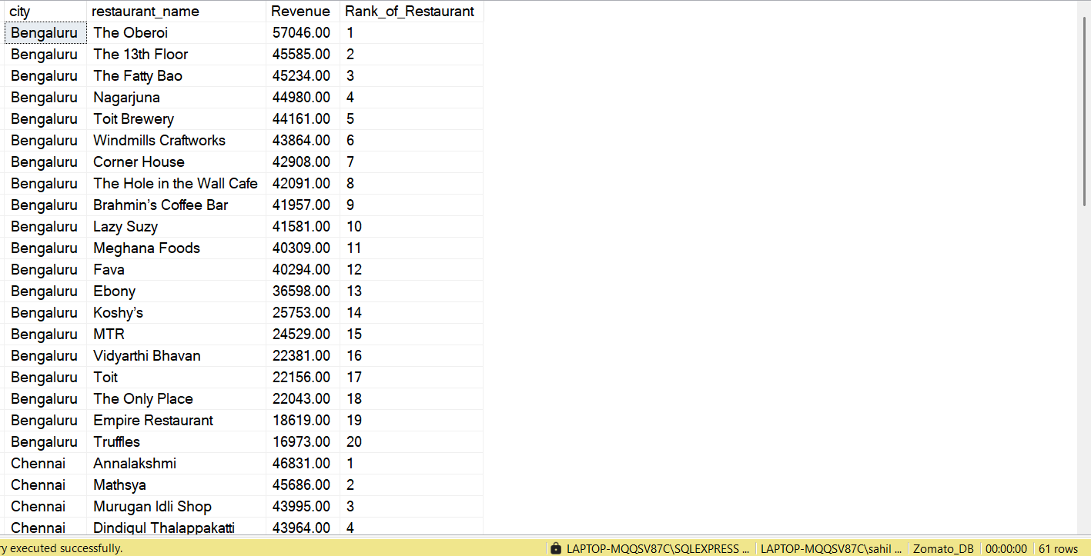

Top 3 Restaurant in their City based on Their Highest Revenue Revenue

WITH Rankin_Table

AS (

SELECT

r.city City,

r.restaurant_name Restaurant,

SUM(o.total_amount) Revenue,

DENSE_RANK() OVER(PARTITION BY city ORDER BY SUM(total_amount) DESC) Rank_of_Restaurant

FROM Orders o

LEFT JOIN Restaurants r

ON r.restaurant_id = o.restaurant_id

WHERE

YEAR(order_date) < 2024

GROUP BY city, r.restaurant_name)

SELECT * FROM Rankin_Table

WHERE Rank_of_Restaurant <= 3

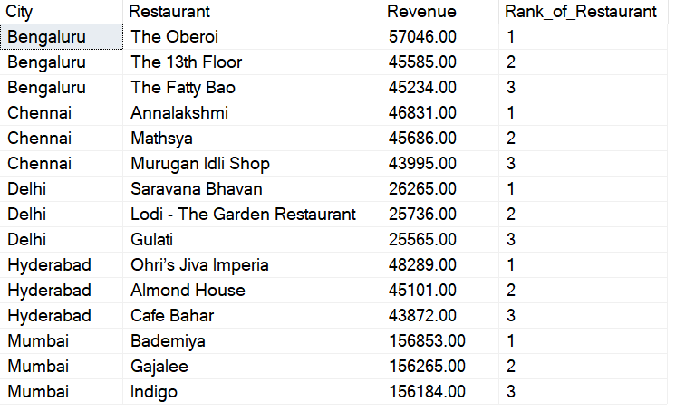

Q7 Most popular dish by City:

Identify the Most Popular dish in each city based on the number of orders

WITH Most_Popular_dish

AS

(SELECT

city,

order_item as Dishes,

COUNT(order_id) Nr_of_Orders,

DENSE_RANK() OVER(PARTITION BY city ORDER BY COUNT(order_id)DESC) Rank_of_Dish

FROM Orders o

LEFT JOIN Restaurants r

ON r.restaurant_id = o.restaurant_id

GROUP BY city, order_item

)

SELECT * FROM Most_Popular_dish

WHERE Rank_of_Dish = 1

ORDER BY

Nr_of_Orders DESC

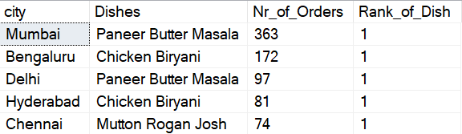

Q8 Customer Churn

Find Customers who haven't placed an order in 2024 but did in 2023

SELECT DISTINCT c.* FROM Orders o

LEFT JOIN Customers c

ON o.customer_id = c.customer_id

WHERE

YEAR(o.order_date) = 2023

AND

c.customer_id NOT IN

(SELECT DISTINCT customer_id FROM Orders

WHERE YEAR(order_date) = 2024)

ORDER BY c.customer_id

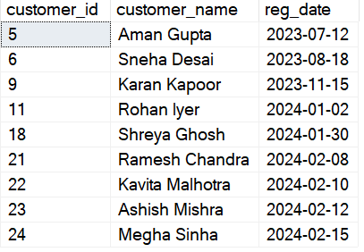

Q9 Cancelled Rate Comparison:

Calculate and Compare the order Cancellation rate for each restaurant between the currrent year and previous year

WITH CANCELLED_RATE

AS

(

SELECT

o.restaurant_id,

COUNT(o.order_id) AS Total_Orders,

COUNT(CASE WHEN d.delivery_id IS NULL THEN 1 END) AS Nr_of_Cancelled_Orders

FROM Orders o

LEFT JOIN Deliveries d

ON d.order_id = o.order_id

WHERE YEAR(o.order_date) = 2023

GROUP BY o.restaurant_id

)

SELECT

restaurant_id,

Total_Orders,

Nr_of_Cancelled_Orders,

CAST(CAST(Nr_of_Cancelled_Orders AS decimal(10,2))

/ CAST(Total_Orders AS decimal(10,2)) * 100 AS decimal(10,2)) AS Cancel_rate

FROM CANCELLED_RATE

ORDER BY Total_Orders DESC

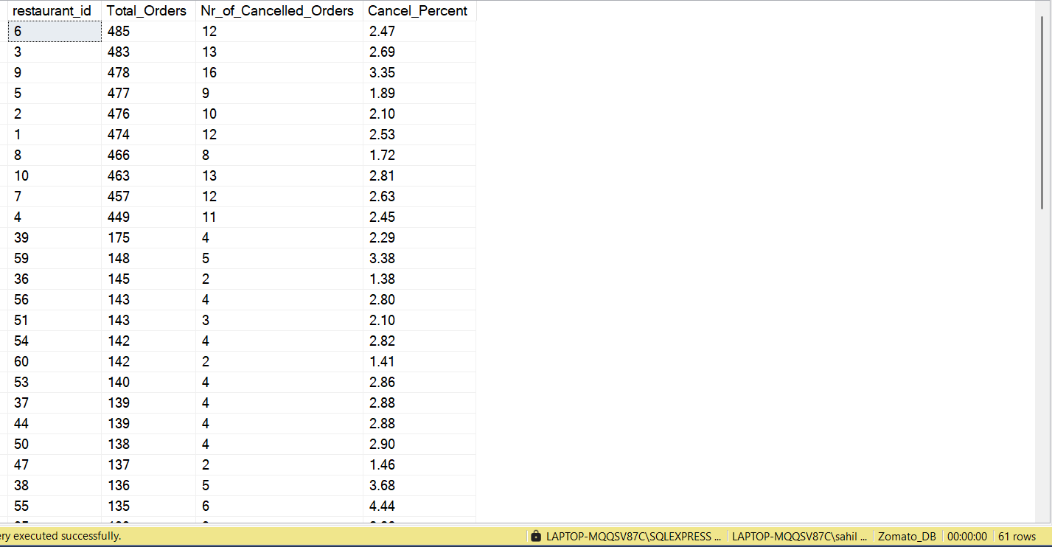

-- Now IF I want to Check Cancellation rate for year 2024

WITH CANCELLED_RATE

AS

(

SELECT

o.restaurant_id,

COUNT(o.order_id) AS Total_Orders,

COUNT(CASE WHEN d.delivery_id IS NULL THEN 1 END) AS Nr_of_Cancelled_Orders

FROM Orders o

LEFT JOIN Deliveries d

ON d.order_id = o.order_id

WHERE YEAR(o.order_date) = 2024

GROUP BY o.restaurant_id

)

SELECT

restaurant_id,

Total_Orders,

Nr_of_Cancelled_Orders,

CAST(CAST(Nr_of_Cancelled_Orders AS decimal(10,2))

/ CAST(Total_Orders AS decimal(10,2)) * 100 AS decimal(10,2)) AS Cancel_rate

FROM CANCELLED_RATE

ORDER BY Total_Orders DESC

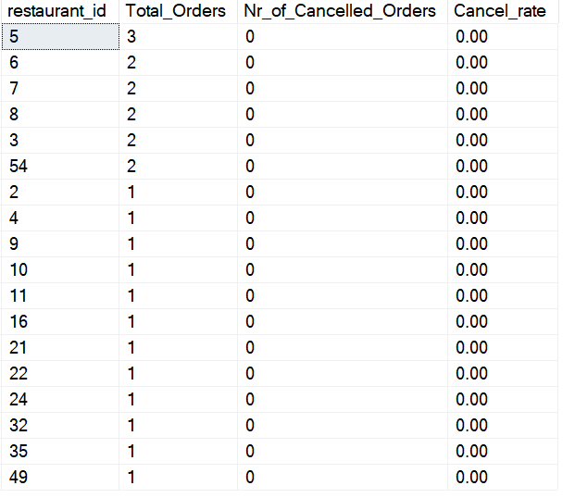

-- Final Solution of Quesiton 9, Rearranging CTEs

WITH CANCELLED_RATE_2023

AS

(

SELECT

o.restaurant_id,

COUNT(o.order_id) AS Total_Orders,

COUNT(CASE WHEN d.delivery_id IS NULL THEN 1 END) AS Nr_of_Cancelled_Orders

FROM Orders o

LEFT JOIN Deliveries d

ON d.order_id = o.order_id

WHERE YEAR(o.order_date) = 2023

GROUP BY o.restaurant_id

),

CANCELLED_RATE_2024

AS

(

SELECT

o.restaurant_id,

COUNT(o.order_id) AS Total_Orders

COUNT(CASE WHEN d.delivery_id IS NULL THEN 1 END) AS Nr_of_Cancelled_Orders

FROM Orders o

LEFT JOIN Deliveries d

ON d.order_id = o.order_id

WHERE YEAR(o.order_date) = 2024

GROUP BY o.restaurant_id

),

Last_Year_Data

AS

(

SELECT

restaurant_id,

Total_Orders,

Nr_of_Cancelled_Orders,

CAST(CAST(Nr_of_Cancelled_Orders AS decimal(10,2))

/ CAST(Total_Orders AS decimal(10,2)) * 100 AS decimal(10,2)) AS Cancel_Percent

FROM CANCELLED_RATE_2023

),

Current_year_Data

AS

(

SELECT

restaurant_id,

Total_Orders,

Nr_of_Cancelled_Orders,

CAST(CAST(Nr_of_Cancelled_Orders AS decimal(10,2))

/ CAST(Total_Orders AS decimal(10,2)) * 100 AS decimal(10,2)) AS Cancel_Percent

FROM CANCELLED_RATE_2024

)

SELECT

cy.restaurant_id,

ly.Cancel_Percent Cancellation_Percent_of_2023 ,

cy.Cancel_Percent Cancel_Percent_of_2024

FROM Current_year_Data cy

JOIN Last_Year_Data ly

ON cy.restaurant_id = ly.restaurant_id

ORDER BY cy.restaurant_id

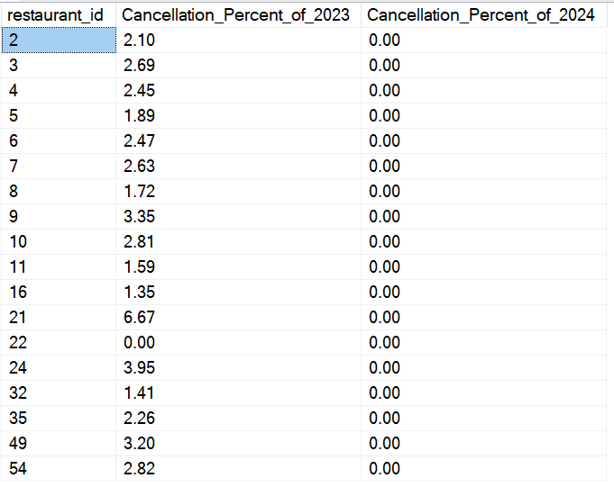

Q10 Rider Average Delivery Time

Determine each rider's average delivery time

WITH Riders_Avg_Delivery_Time

AS

(

SELECT

r.rider_id,

r.rider_name,

o.order_time,

d.delivery_time,

CAST(CASE

WHEN d.delivery_time < o.order_time THEN (1440 – ABS(DATEDIFF(MINUTE,order_time,d.delivery_time)))

ELSE ABS(DATEDIFF(MINUTE,order_time,d.delivery_time))

END as decimal(10,2)) Time_Taken_to_deliver

FROM Orders o

LEFT JOIN Deliveries d ON o.order_id = d.order_id

LEFT JOIN Riders r ON d.rider_id = r.rider_id

WHERE d.delivery_status = 'Delivered'

)

SELECT

rider_id,

rider_name,

CAST(ROUND(AVG(Time_Taken_to_deliver),2) AS decimal(10,2)) AS Avg_Time_By_Riders_in_MINs

FROM Riders_Avg_Delivery_Time

GROUP BY rider_id, rider_name

ORDER BY rider_id

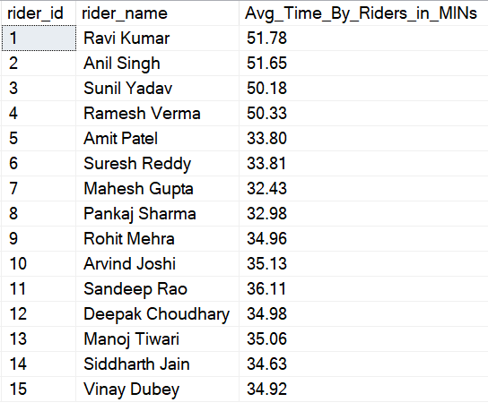

Q11 Monthly Restaurant Growth Ratio:

Calculate each restaurant's growth ratio based on the total number of delivered orders since its joining

WITH Growth_Rate_of_Delived_Orders

AS

(

SELECT

o.restaurant_id,

YEAR(o.order_date) Order_year,

MONTH(o.order_date) Order_Month,

FORMAT(o.order_date, 'MMM yyyy') AS Month_year,

CAST(COUNT(d.delivery_id) AS decimal(10,2)) AS Current_Month_Orders_Delivered,

CAST(LAG(COUNT(d.delivery_id)) OVER(PARTITION BY o.restaurant_id

ORDER BY YEAR(o.order_date),MONTH(o.order_date)) AS decimal(10,2)) Prev_Month_Orders_delivered

FROM Orders o

LEFT JOIN Deliveries d

ON o.order_id = d.order_id

WHERE d.delivery_status = 'Delivered'

GROUP BY

o.restaurant_id,

YEAR(o.order_date),

MONTH(o.order_date),

FORMAT(o.order_date, 'MMM yyyy')

)

SELECT

restaurant_id,

Month_year,

Current_Month_Orders_Delivered,

Prev_Month_Orders_delivered,

ROUND(CAST((Current_Month_Orders_Delivered - Prev_Month_Orders_delivered)/Prev_Month_Orders_delivered * 100 AS decimal(10,2)),2) as Grow_Rate_in_Orders_Delivered

FROM Growth_Rate_of_Delived_Orders

ORDER BY

restaurant_id,

Order_year,

Order_Month

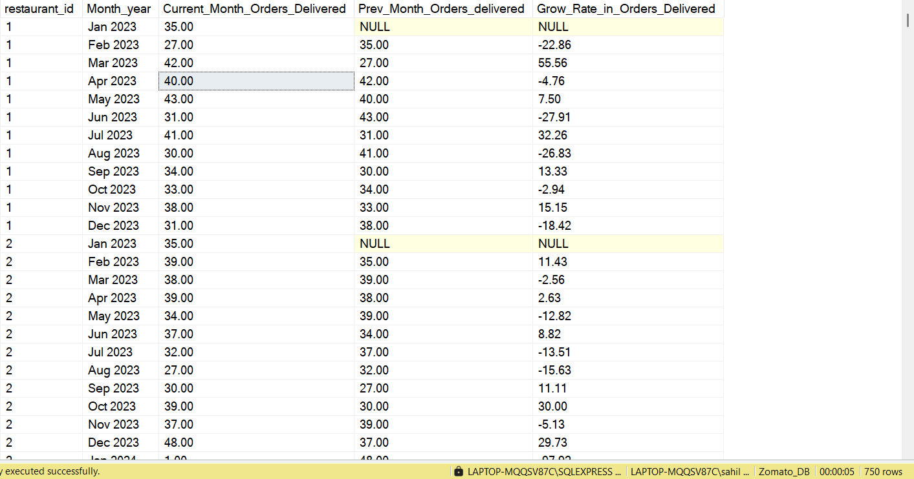

Q12 Customer Segmentations:

(1) Segment Customers into "Gold" or "Silver" groups based on their total spending

(2) Compare to the Average Order Value

If Customer's total spending exceeds AOV Label them with gold other wise label them as silver

Write a Query to Determine each segment's total number of orders and total revenue

SELECT

Customer_Category,

SUM(Total_Spend) Total_Revenue,

SUM(Nr_of_Orders) Total_Orders

FROM

(

SELECT

c.customer_name,

COUNT(o.order_id) Nr_of_Orders,

SUM(o.total_amount) Total_Spend,

CASE

WHEN SUM(o.total_amount)> (SELECT AVG(total_amount) from Orders) THEN 'Gold'

ELSE 'Silver'

END as Customer_Category

FROM Orders o

JOIN Customers c

ON c.customer_id = o.customer_id

GROUP BY

c.customer_id,

c.customer_name

) as t2

GROUP BY Customer_Category

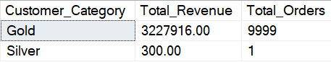

Q13 Rider Monthly Earning:

Calculate each ride's total monthly earnings, assuming they earn 8% of the Delivered Order Amount

WITH Riders_Monthly_Earning

AS

(SELECT

rd.rider_id ,

rd.rider_name,

YEAR(o.order_date) Order_year,

Month(o.order_date) Order_Month,

FORMAT(o.order_date,'MMMM yyyy') Month_year,

CAST(SUM(total_amount) * 0.08 AS decimal(10,2)) Total_Earning_of_Rider

FROM Orders o

LEFT JOIN Deliveries d

ON d.order_id = o.order_id

LEFT JOIN Riders rd

ON rd.rider_id = d.rider_id

WHERE d.delivery_status = 'Delivered'

GROUP BY

rd.rider_id,

rd.rider_name,

YEAR(o.order_date),

Month(o.order_date),

FORMAT(o.order_date,'MMMM yyyy')

)

SELECT rider_id, rider_name, Month_year, Total_Earning_of_Rider FROM Riders_Monthly_Earning

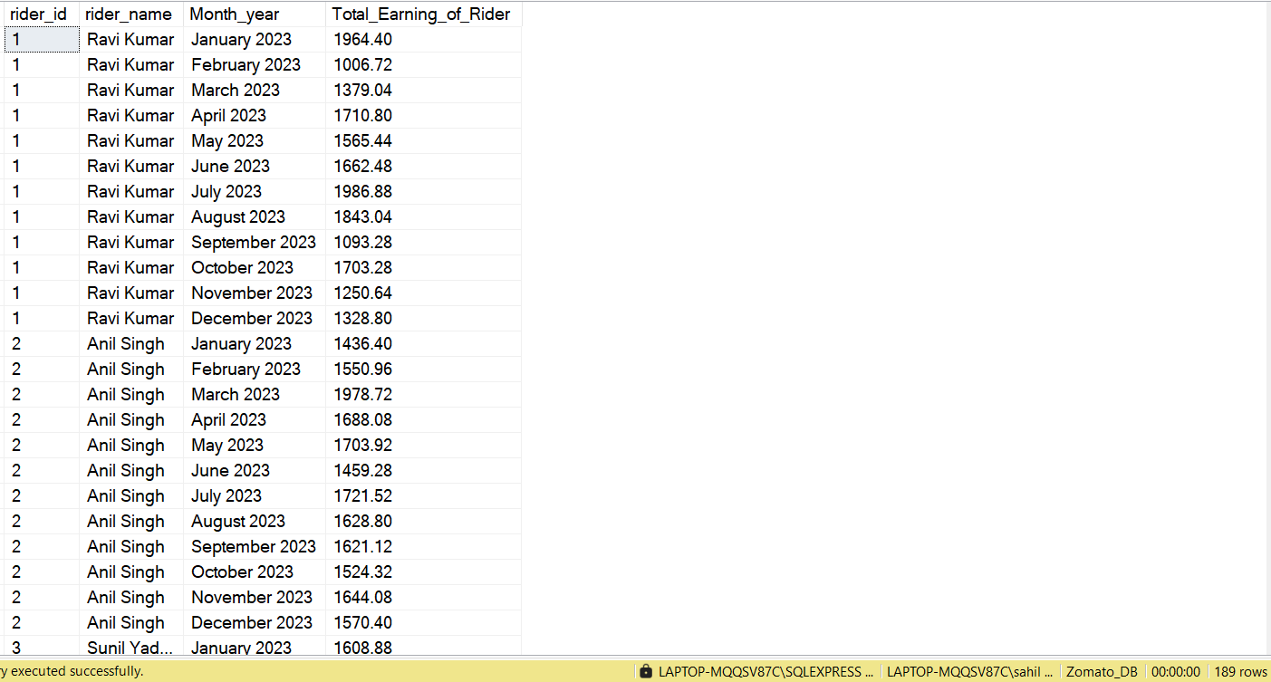

Q 14 Rider Rating Analysis:

Find the number of 5 Star. 4 star, and 3 star rating Each riders has.

Riders recieve this rating based on delivery time

IF orders are delivered less than 15 Minutes of order recieved time the rider get 5 star rating.

IF they delivery is 15 to 20 Minute then they get a 4 star rating

IF they deliver after 20 Minute they get 3 star rating.

WITH Main_cte

AS

(

SELECT

d.rider_id as Rider_id,

o.order_time Order_time,

d.delivery_time,

CASE

WHEN d.delivery_time < o.order_time THEN (1440 - ABS(DATEDIFF(MINUTE,order_time,d.delivery_time)))

ELSE ABS(DATEDIFF(MINUTE,order_time,d.delivery_time))

END Time_taken_to_Deliver

FROM Orders o

JOIN Deliveries d

ON o.order_id = d.order_id

WHERE d.delivery_status = 'Delivered'

),

Final

AS

(

SELECT Rider_id,

CASE

WHEN Time_taken_to_Deliver <=15 THEN '5 star'

WHEN Time_taken_to_Deliver > 15 AND Time_taken_to_Deliver <= 20 THEN '4 Star'

ELSE '3 Star'

END STARS,

Time_taken_to_Deliver

FROM Main_cte

)

SELECT

Rider_id,

STARS,

COUNT(STARS) Total_Stars

FROM Final

GROUP BY

Rider_id,

STARS

ORDER BY

Rider_id,

COUNT(STARS) DESC

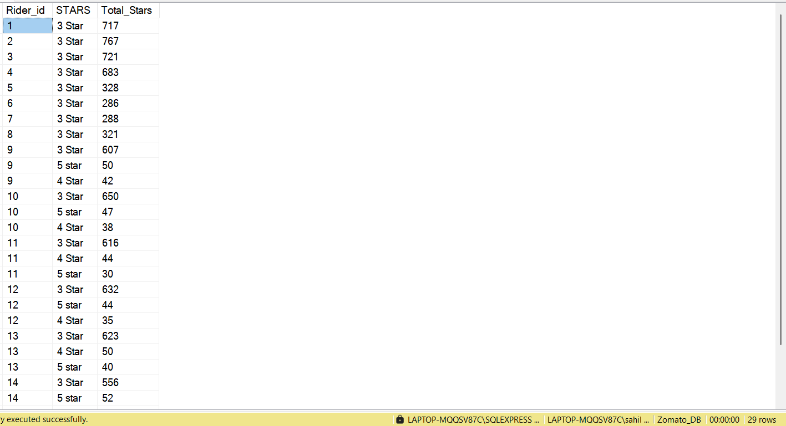

Q 15 Order Frequency by Day:

Analyze order fequency per day of the week and identify the peak day for each restaurant

WITH Peak_day_for_Restaurant

AS

(

SELECT

o.restaurant_id,

r.restaurant_name as Restaurant,

DATEPART(WEEKDAY,o.order_date) Week_number,

DATENAME(WEEKDAY, o.order_date) Weekday_name,

COUNT(o.order_id) Nr_of_Orders,

DENSE_RANK() OVER(PARTITION BY o.restaurant_id

ORDER BY COUNT(o.order_id) DESC ) as Rank_of_Week_Day

FROM Orders o

LEFT JOIN Restaurants r

ON r.restaurant_id = o.restaurant_id

GROUP BY o.restaurant_id,

r.restaurant_name,

DATENAME(WEEKDAY, o.order_date),

DATEPART(WEEKDAY,o.order_date)

)

SELECT Restaurant, Weekday_name, Nr_of_Orders, Rank_of_Week_Day FROM Peak_day_for_Restaurant

WHERE Rank_of_Week_Day = 1

ORDER BY Nr_of_Orders DESC

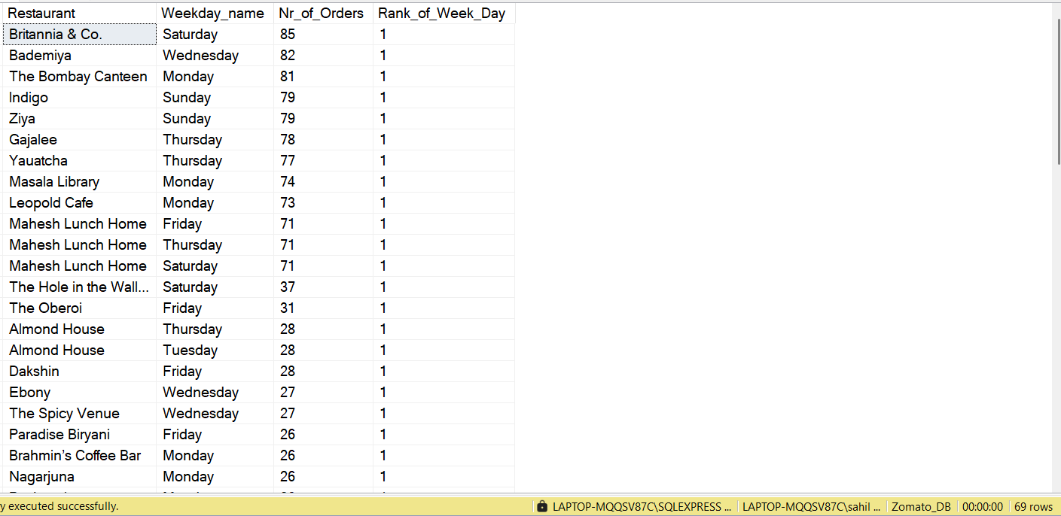

Q16 Customer Lifetime value(CLV)

Calculate the Total Revenue Generated by each customer over all their orders

SELECT

c.customer_id,

c.customer_name,

SUM(o.total_amount) Customer_Lifetime_Value FROM Orders o

JOIN Customers c

ON c.customer_id = o.customer_id

GROUP BY c.customer_id, c.customer_name

ORDER BY

SUM(o.total_amount) DESC

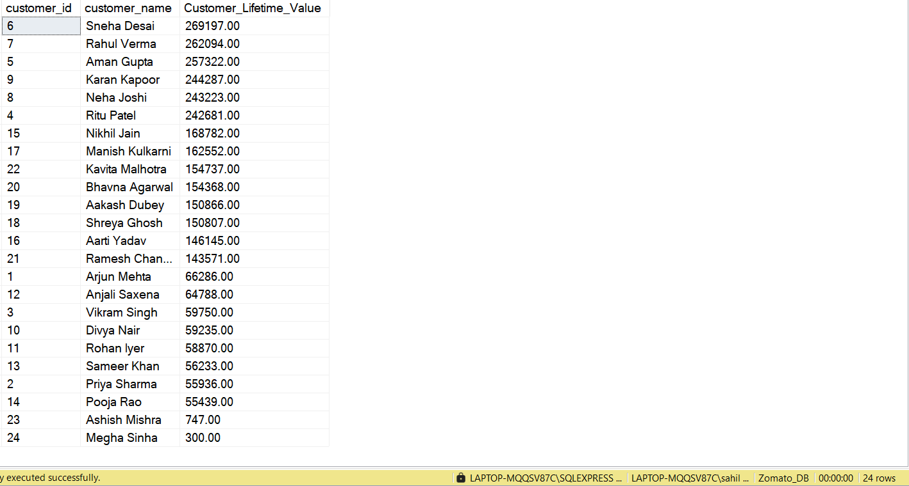

Q 17 Monthly Sales Trends:

Identify Sales Trends by Comparing each month's total Sales to the previous months

WITH Monthly_Sales_Trends

AS

(

SELECT

YEAR(order_date) Year,

MONTH(Order_date) Month_Number,

DATENAME(MONTH,Order_date) Month_Name,

SUM(total_amount) Current_Month_Sales,

LAG(SUM(total_amount)) OVER(ORDER BY MONTH(Order_date)) Prev_Month_Sales

FROM Orders

GROUP BY

DATENAME(MONTH,Order_date),

YEAR(order_date),

MONTH(Order_date)

)

SELECT

Year,

Month_Name,

Prev_Month_Sales,

Current_Month_Sales,

CAST(ROUND((Current_Month_Sales- Prev_Month_Sales)/Prev_Month_Sales* 100,2)AS decimal(10,2)) Percent_Growth_In_Sales

FROM Monthly_Sales_Trends

ORDER BY

Year, Month_Number

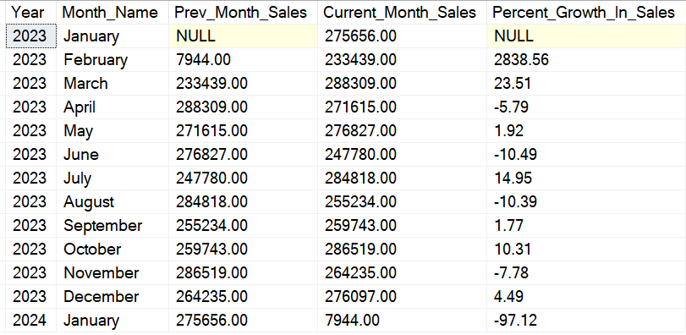

Q 18 Rider Effeciency

Evaluate rider Effeciency by determining Average Delivery times and Identifying those with lowest And highest Average Delivery time

SELECT -- By this You will get Minimum and Maximum Average time taken to deliver

MIN(Avg_Time_Taken_to_Deliver) Min_Avg_Time_taken_to_deliver,

MAX(Avg_Time_Taken_to_Deliver) Max_Avg_Time_taken_to_deliver

FROM

( -- By this Subquery you will get Average Time taken by Riders

SELECT Rider_Id, Rider_Name, CAST(ROUND(Avg_Time_taken_to_Deliver,2) AS decimal(10,2)) AS Avg_Time_Taken_to_Deliver FROM

(

SELECT

r.rider_id as Rider_Id,

rider_name as Rider_Name,

AVG(CAST(CASE

WHEN d.delivery_time < o.order_time THEN (1440 - ABS(DATEDIFF(MINUTE,order_time,d.delivery_time)))

ELSE ABS(DATEDIFF(MINUTE,order_time,d.delivery_time))

END as decimal(10,2))) Avg_Time_taken_to_Deliver

FROM Orders o

LEFT JOIN Deliveries d

ON o.order_id = d.order_id

LEFT JOIN Riders r

ON r.rider_id = d.rider_id

WHERE

d.delivery_status = 'Delivered'

GROUP BY r.rider_id,rider_name

) as t1

-- ORDER BY Avg_Time_taken_to_Deliver DESC

)t2

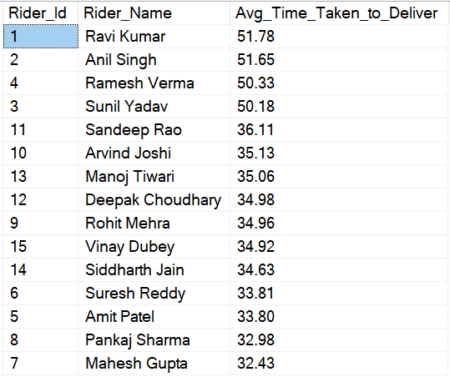



Q19 Order Item Popularity :

Track the Popularity of specific order items over time and identify seasonal demand spike

SELECT order_item,Season, COUNT(order_id) Nr_of_Orders

FROM (

SELECT

*,

CASE

WHEN MONTH(order_date) BETWEEN 3 AND 5 THEN 'Summer'

WHEN MONTH(order_date) BETWEEN 6 AND 9 THEN 'Monsoon'

WHEN MONTH(order_date) BETWEEN 10 AND 11 THEN 'Autumn'

WHEN MONTH(order_date) IN ( 11, 12, 1, 2) THEN 'Winter'

END Season

FROM Orders

) t1

GROUP BY order_item,

Season

ORDER BY

order_item,

Nr_of_Orders DESC

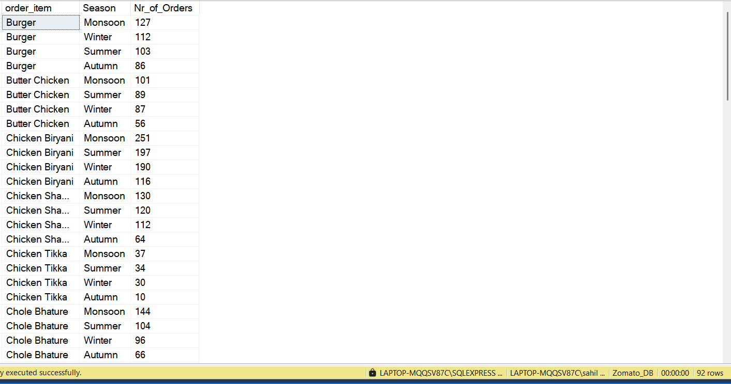

Q 20 Rank each City based on the Total revenue for last year 2023

SELECT

r.city,

SUM(o.total_amount) Total_Revenue,

RANK() OVER(ORDER BY SUM(o.total_amount) DESC) Rank_of_City_by_Revenue

FROM Orders o

LEFT JOIN Restaurants r

ON r.restaurant_id = o.restaurant_id

WHERE YEAR(order_date) = 2023

GROUP BY r.city

